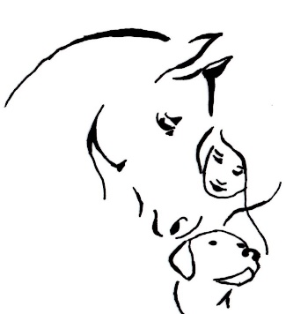

Healing Body WoRx

MAGNAWAVE Certified for People, Dogs & Horses

EQUISSAGE (Equine Massage) Certified

Jamestown TN 405-200-4214

* Reduce Inflammation
* Increase oxygenation
* Improve circulation
* Increase range of motion
* Enhance stamina/strength

Healing Body oRx

405-200-4214

* Pain relief
* Eliminate toxins
* Speed healing
* Quicker recovery from muscle/tendon/ligament/bone injuries

Healing Body WoRx

405-200-4214

Healing Body WoRx

405-200-4124

Healing Body WoRx

405-200-4214

Healing Body WoRx

405-200-4214

Healing Body WoRx

405-200-4214

Healing Body WoRx

405-200-4214

Healing Body WoRx

405-200-4214

Healing Body WoRx

405-200-4214

Healing Body WoRX

405-200-4214

Healing Body WoRx

405-200-4214